**DAILY ONLINE ACTIVITIES SUMMARY**

|  |  |  |  |  |  |  |  |  |
| --- | --- | --- | --- | --- | --- | --- | --- | --- |
| **Date:** | **25-06-2020** | | | | | **Name:** | **Deril Quadras** | |
| **Sem & Sec** | **8 A** | | | | | **USN:** | **4AL16CS031** | |
| **Online Test Summary** | | | | | | | | |
| **Subject** | | **-** | | | | | | |
| **Max. Marks** | | **-** | | **Score** | | | **-** | |
| **Certification Course Summary** | | | | | | | | |
| **Course** | **AWS Sydney Summit.** | | | | | | | |
| **Certificate Provider** | | | **AWS** | | **Duration** | | | **30 mins** |
| **Coding Challenges** | | | | | | | | |
| **Problem Statement:**   1. **Write a C Program to Fibonacci using recursion** | | | | | | | | |
| **Status: Solved** | | | | | | | | |
| **Uploaded the report in Github** | | | | | **Yes** | | | |
| **If yes Repository name** | | | | | **Derilquadras/online_c_coding_repository** | | | |
| **Uploaded the report in slack** | | | | | **Yes** | | | |

Online Test Details:

Not Conducted

Certification Course Details:

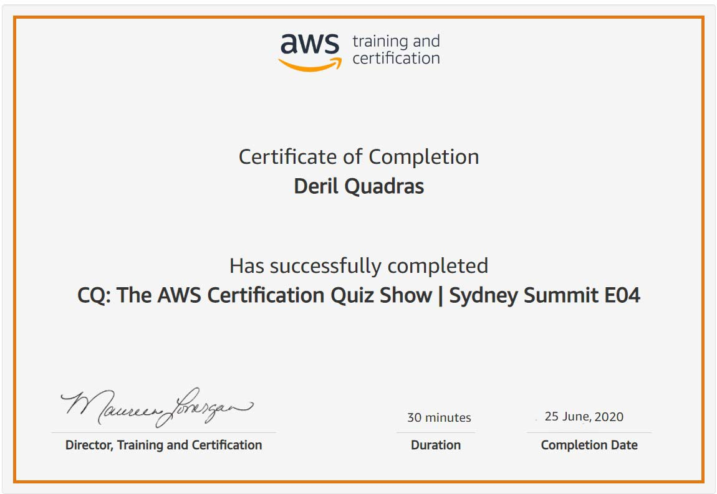

Coding Challenges Details:

**PROGRAM 1 .**

**//Fibonacci using recursion**

**#include<stdio.h>**

**int Fibonacci(int);**

**int main()**

**{**

**int n, i = 0, c;**

**printf("enter the number of elements\n");**

**scanf("%d",&n);**

**printf("%d",n);**

**printf("\nFibonacci series\n");**

**for ( c = 1 ; c <= n ; c++ )**

**{**

**printf("%d\n", Fibonacci(i));**

**i++;**

**}**

**return 0;**

**}**

**int Fibonacci(int n)**

**{**

**if ( n == 0 )**

**return 0;**

**else if ( n == 1 )**

**return 1;**

**else**

**return ( Fibonacci(n-1) + Fibonacci(n-2) );**

**}**